# *Software Requirements Specification*

# *Product sales analysis for online companies using customer reviews and feedback*



**Authors**

*Danial Shabbir (FA16-BSE-085)*

*Syed Shamsuddin Gellani (FA16-BSE-059)*

*Dawood Khan (FA16-BSE-043)*

**Affiliation**

*COMSATS University Islamabad, Wah Campus*

27-Dec-2019

## Introduction

## This section will discuss the purpose, scope, overview and business context of this project.

**1.1 Purpose of this document**

The intended audience are Developers, Database Administrators, Administrators, and Researcher

* 1. **Scope of this document**

The document will provide detailed user requirements. The specification of the requirements will give the direction of the project. The infrastructure of the project will be based on the document. The developing team will be clear that what they have to develop and how. The user could match the project with its requirements using the document.

**1.3 Overview**

For continuous improvement most of the businesses relies on customer feedbacks so as the name of project shows it’s a product that will be performing analysis on the customer feedback & review of a specific product of online company. The main purpose is to help companies improve their product’s sale and ultimately analysis through real time data (customer feedback) is presented through powerful visuals

* 1. **Business Context**

This project aims to help existing online business to analyze their customer behavior against a specific product so, they can better deliver their products to a group of people with common interest more effectively. Hence, increasing their sales and affect on market.

## 2. General Description

**2.1 Product Functions**

The product will perform analysis on feedbacks and reviews of customer with the help of natural language processing techniques. This will help us to understand how a customer feels or thinks about a specific product? The analytics from real time data will be displayed using powerful visualizations tools and will help us to predict the customer satisfaction score as well as product success score.

**2.2 Similar System Information**

This product is standalone but can be used by other products as a plugin. Describes the relationship of this product with any other products. Specifies if this product is intended to be stand-alone, or else used as a component of a larger product. If the latter, this section discusses the relationship of this product to the larger product.

**2.3 User Characteristics**

Users with the basic knowledge of web based or android platforms, can use this system, no deep knowledge about software systems is required to use this system. The user should know how to give input to the interface. Our primary consumers are decision makers of the company (CEO, CTO, COO) or people from marketing department.

**2.4 User Problem Statement**

The problem that most of the user’s face is how to use a product? because of unfriendly visual design and another problem is complex language used in products which makes understanding of system very difficult.

**2.5 User Objectives**  
The user wants the product which is easy to understand and easy to use. Simple language is used and analytical data shown using effective graphs and charts.

**2.6 General Constraints**

The designer should design a system that is eye catching. The system should be responsive and proud user great experience.

## Functional Requirements

This section lists the functional requirements in ranked order from more important to least important.

1. **Natural Language Processing Model**
   1. **Description**  
      This is the core module of our product which will analyze the customer review and will perform sentiment analyses, based on the output of this model we will be able to provide important insights
   2. **Criticality**  
      Very High
   3. **Technical issues**  
      High processing power & quick response time is required since a lot of data is to be processed
   4. **Cost and schedule**  
      Google Cloud will be used as a server for the execution of model and it may vary according to the processing & storage of dataset
   5. **Risks**
      1. Wrong Data / Dirty Data
      2. No Load Balancing
      3. Security Vulnerability
      4. Versioning Issue
   6. **Dependencies with other requirements**  
      Highly dependent on data pre-processing module
2. **Data Pre-processing Module**
   1. **Description**  
      This module will help us sanitize and clean the raw data and will convert it to common data structure, which will help NLP Module to work efficiently.
   2. **Criticality**  
      Very High
   3. **Technical issues**  
      High processing power & quick response time is required since a lot of data is to be cleaned and processed
   4. **Cost and schedule**  
      Google Cloud will be used as a server for the execution of model and it may vary according to the processing & storage of dataset
   5. **Risks**
      1. New Raw Data
      2. No Load Balancing
3. **Scrapper**
   1. **Description**  
      This module is responsible for raw data gathering, which will be the input of data pre-processing module. This will create new thread for each of the sites with potential customer review & feedback
   2. **Criticality**  
      High
   3. **Technical issues**  
      High processing power with high bandwidth for quick response time. since a lot of data is to be scrapped from different sources
   4. **Cost and schedule**  
      Google Cloud will be used as a server for the execution of model and it may vary according to the processing & storage of dataset
   5. **Risks**
      1. Offline website from where we want to scrape data
4. **Android / iOS Interface**
   1. **Description**  
      This interface is required for taking product’s information and based on that information our scrapper will gather and scrape data from different sources
   2. **Criticality**  
      Medium
   3. **Technical issues**  
      Internet dependency
   4. **Cost and schedule**
      1. Phone should be in good condition as well as have fast processing
      2. Play store & App store deployment cost.
      3. Fire store premium subscription
   5. **Risks**
      1. Security Vulnerability
5. **Website Interface**
   1. **Description**  
      This interface is required for taking product’s information and based on that information our scrapper will gather and scrape data from different sources
   2. **Criticality**  
      Medium
   3. **Technical issues**
      1. Internet dependency
      2. Modern browser which support AJAX calls
   4. **Cost and schedule**
      1. Deployment costs
      2. Theme costs
   5. **Risks**
      1. Security Vulnerability
      2. Old Browser without AJAX Support
6. **Analytics Dashboard**
   1. **Description**  
      This dashboard will provide the insights returned from NLP Module and will display it in the form of pictorial representation e.g. graphs, chart.
   2. **Criticality**  
      Medium
   3. **Technical issues**  
      Data Integrity dependency
   4. **Cost and schedule**
      1. No Cost since charting libraries are free
   5. **Risks**
      1. Data Integrity

**Oher requirements**  
Highly dependent on data pre-processing module

**Dependencies with other requirements**  
Highly dependent on data pre-processing module 4.

## Interface Requirements

In this section we have discussed the interface requirements

* **4.1 User Interfaces**  
  Describes how this product interfaces with the user.
  + **4.1.1 GUI**  
    Describes the graphical user interface if present. This section should include a set of screen dumps or mockups to illustrate user interface features. If the system is menu-driven, a description of all menus and their components should be provided.
  + **4.1.2 CLI**  
    For remote server access from developer’s pc to google cloud we will use SSH client (PuTTY) which is a cli based interface.
  + **4.1.3 API**  
    Cloud Translation documentation is a google API which would be used for language translation. Customer feedback will be input which would translate to English by this API.
  + **4.1.4 Diagnostics or ROM**  
    Debugging information and diagnostic data will be stored in a log file only accessible by the developers on google cloud
* **4.2 Hardware Interfaces**  
  There are no hardware interfaces
* **4.3 Communications Interfaces**  
  To communicate the web and android/ios app with google cloud we will use RESTFULL APIS interface.
* **4.4 Software Interfaces**
  + Analytics Dashboard
  + Authentication
  + Cloud CLI Interfaces
  + Admin Side Business Registry

## 5. Performance Requirements

React.js is a Java script framework which will make our product much more optimized because it is small and minified use much more recursive syntax. Materialize CSS front end should be use because it provides amazing UX and UI. The main important reason to use it is that it is based on Google Material Design which suggests Ease of Access for user. Python will be used for fast data pre-processing since it has Numpy and Pandas which can perform operation on matrices in milliseconds on large datasets. Performance degradation will be efficiently managed.

## 6. Design Constraints

Specifies any constraints for the design team using this document.

**6.1 Standards Compliance**

Coloring Scheme should be green and white

Material Design Should be followed

**6.2 Graphs**

Graphs should be 2-dimensional since human eye can perceive 2-d space.

**6.3 Aesthetics**

Display the registered company logo in the dashboard

The background should be transparent

## 7. Other non-functional attributes

Specifies any other particular non-functional attributes required by the system. Examples are provided below.

**7.1 Security**

The system is protected by any kind of hacker attack. Only authentic users will be granted access to use the system. If a user forgets password then user will be allowed to update their password by sending link to their primary mail.

**7.2 Reliability**

The system will not crash due to any bugs or unusual input. The mean time between failure willzbe higher and probability of failure on demand shall be 0.00001(1 out of 100000) when a user request to check analytics.

**7.3 Reusability**

The system core functionalities can be easily reused for further addition of new features. This will updating the system easy and a lot of time will be saved by not coding from scratch.

**7.4 Application Affinity/Compatibility**

The system will work on widely used latest versions of browsers e.g chrome, firefox, opera and safari etc and the user can use it on any android and iOS version of latest phones.

**7.5 Serviceability**

If any Error or crash occurs then user shall be allowed to send report via mail. A user shall be allowed to request for a detailed analytics of their product.

**7.6 UI/UX Enhanced**

The UI of the system is kept very simple and easy to understand. User can easily navigate through site without getting confused.

**7.7 Responsiveness**

The system shall take no more than 3seconds while user is logging or registering to the system. The analytics shall be shown in less then 2minutes.

## 8. Preliminary Object-Oriented Domain Analysis

* **8.1 Inheritance Relationships**

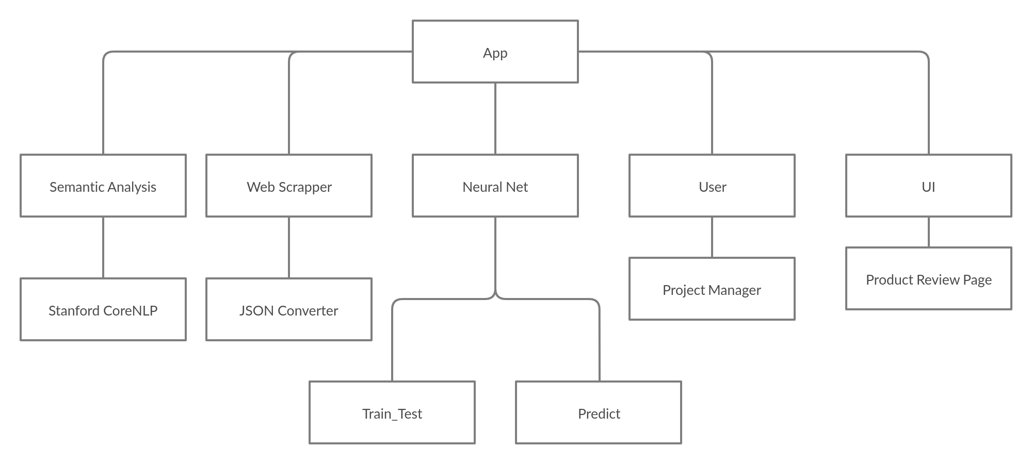

* **8.2 Class descriptions**  
  This section presents a more detailed description of each class identified during the OO Domain Analysis. For more details on the process giving rise to these descriptions, see [Lecture 5.3: OO Domain Analysis](http://www2.ics.hawaii.edu/~johnson/413/lectures/5.3.html) and/or texts on object-oriented software development.

Each class description should conform to the following structure:

* 1. **8.2.1 <*App*>**
     1. **8.2.1.1 Abstract or Concrete:**   
        Concrete Class
     2. **8.2.1.2 List of Superclasses:**   
        No super classes.
     3. **8.2.1.3 List of Subclasses:**   
        Semantic_Analysis,Web_Scrapper, Neural_Net,User,UI
     4. **8.2.1.4 Purpose:**   
        Class is responsible for abstraction purposes
     5. **8.2.1.5 Collaborations:**   
        No dependency
     6. **8.2.1.6 Attributes:**   
        Log,Process_Time
     7. **8.2.1.7 Operations:**   
        Running different instance of subclasses on different servers.
     8. **8.2.1.8 Constraints:**   
        There are no constraints for this class

## 9. Operational Scenarios

## 9.1 Use Case Diagram

## use case diagram for android, iPhone and website

## 

## 9.2 Class Diagram

## 

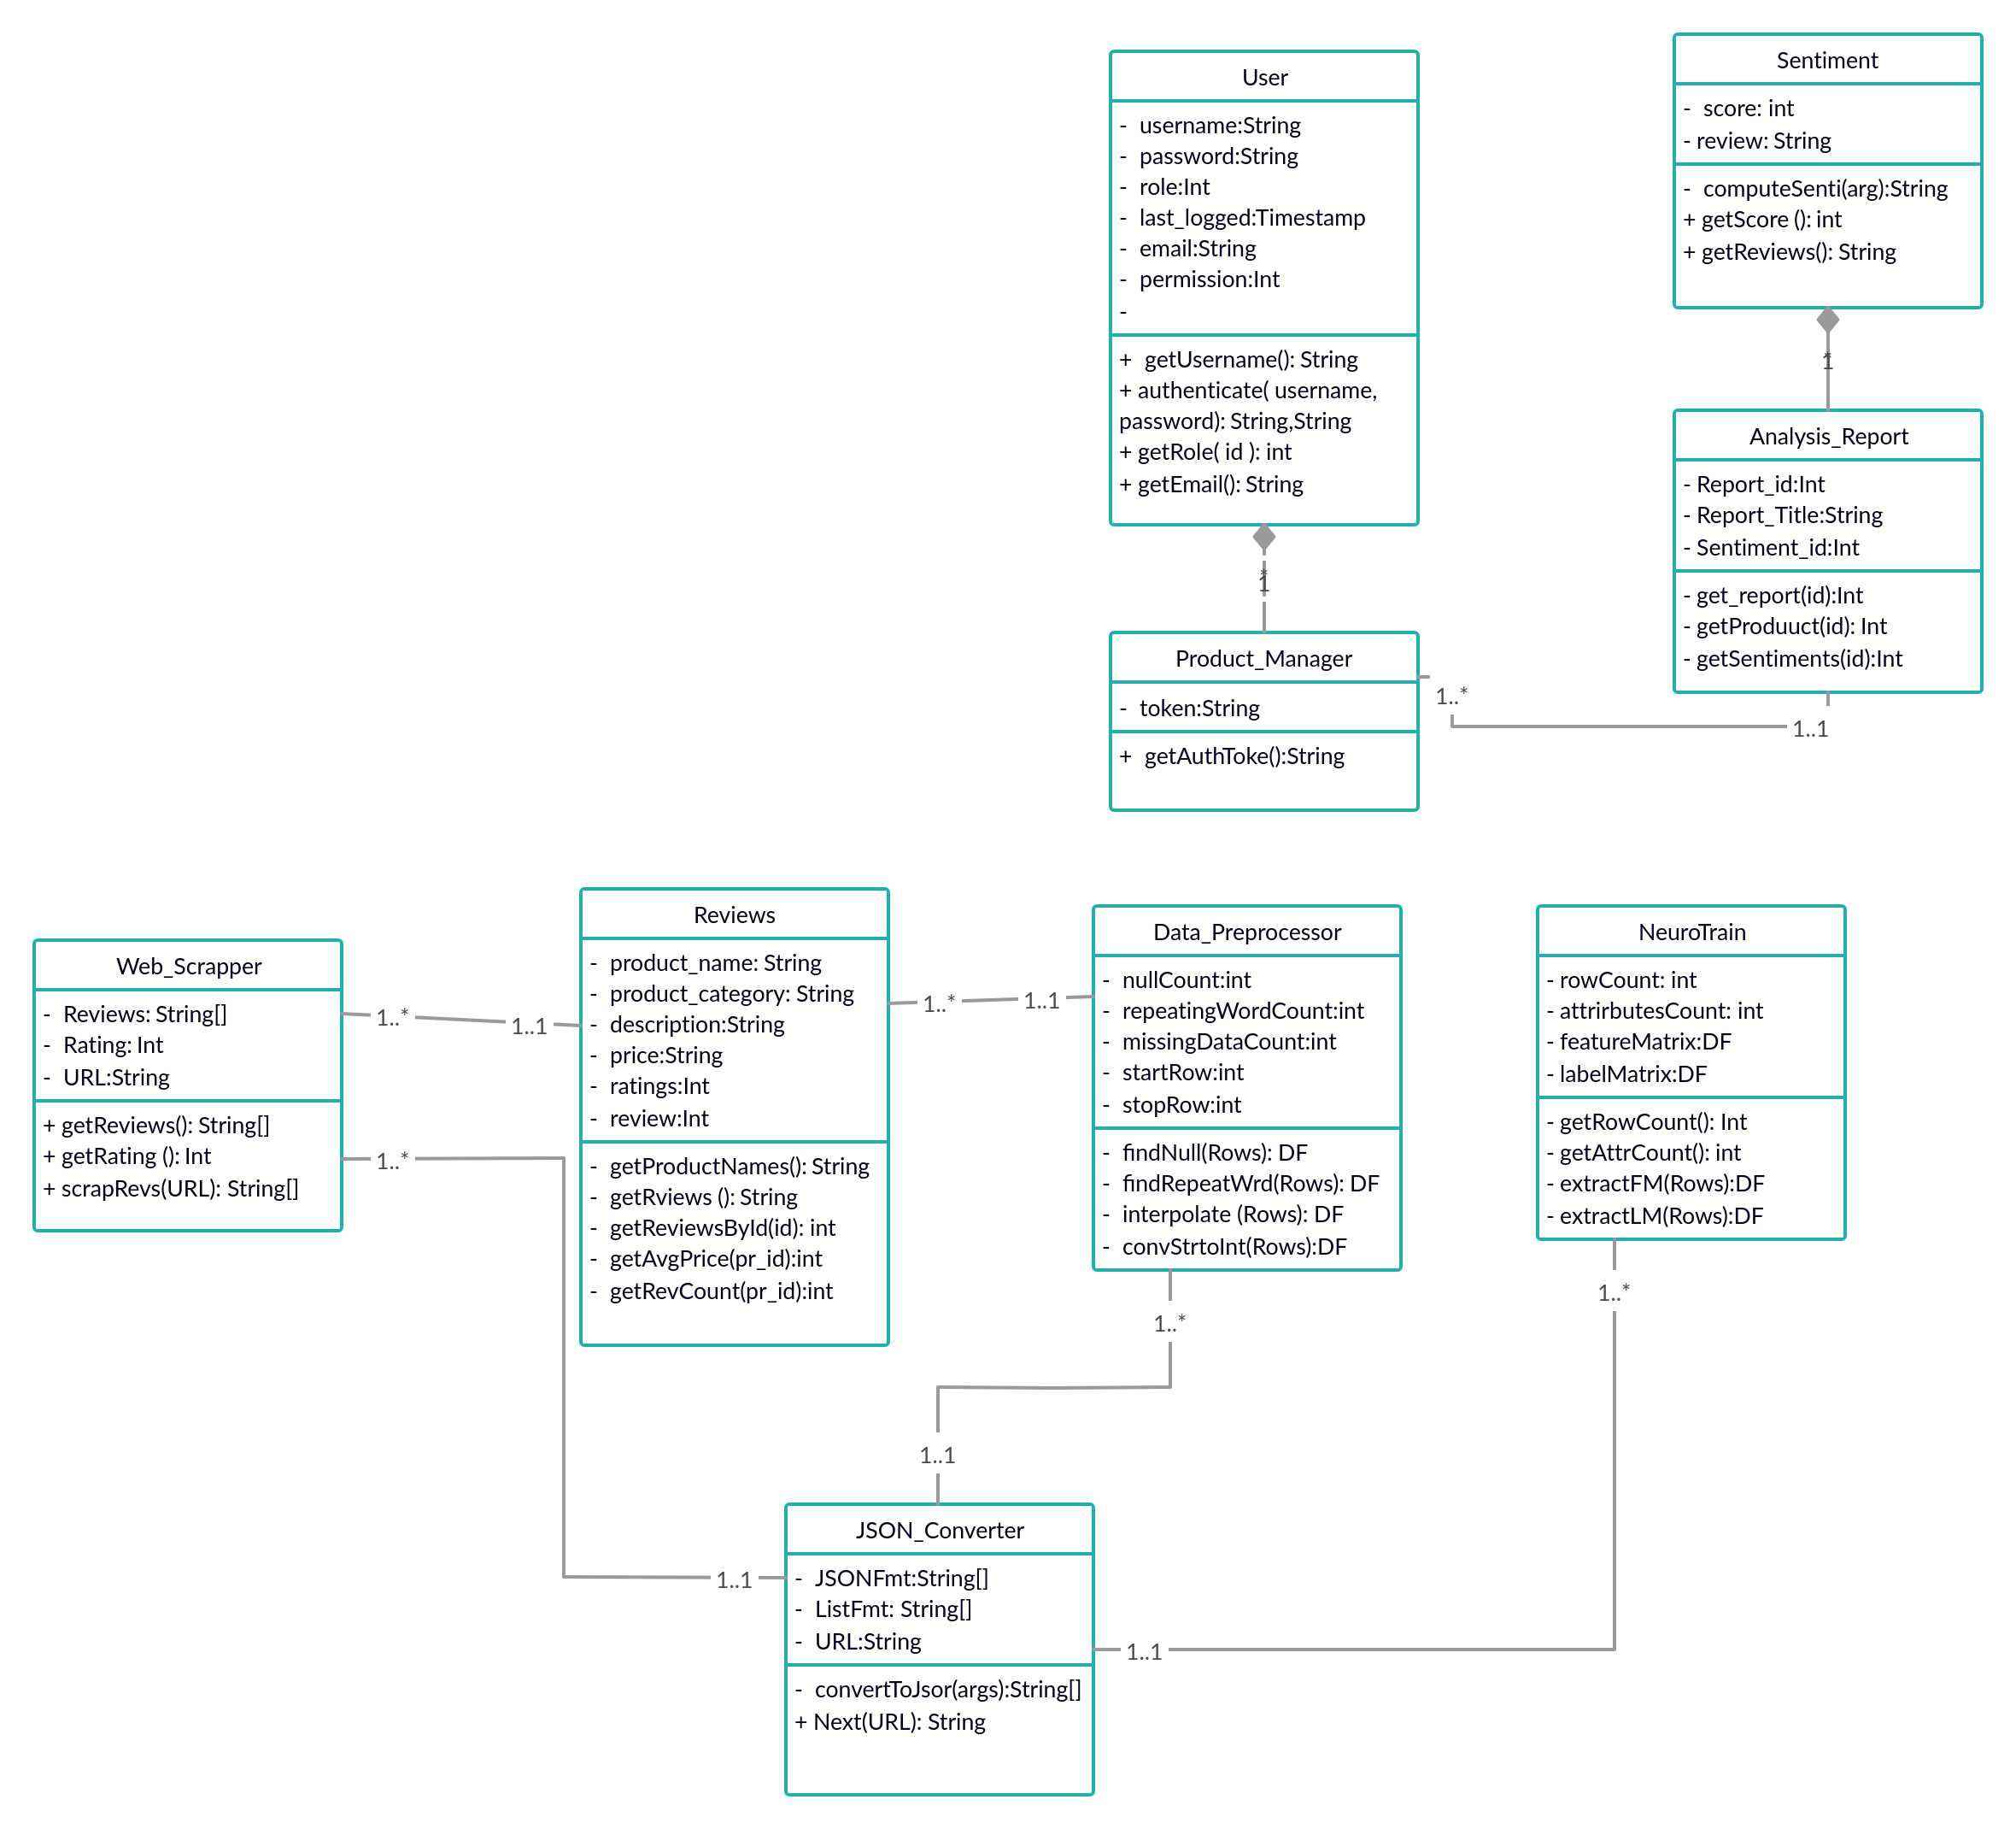

## 9.3 Activity Diagram

**Activity diagram for user login & register**

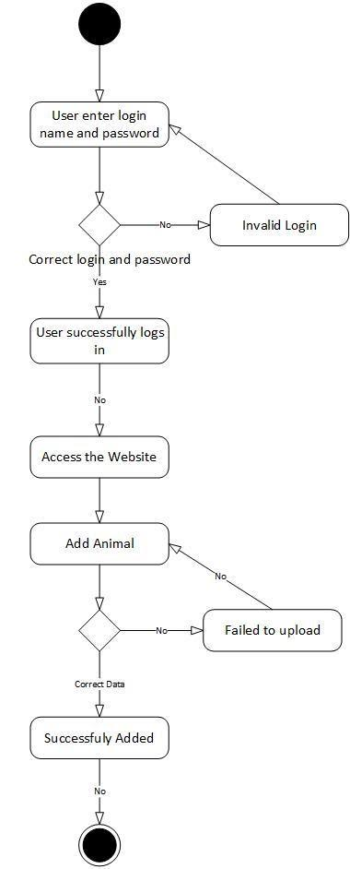

**Activity diagram for semantic analysis and product success prediction**

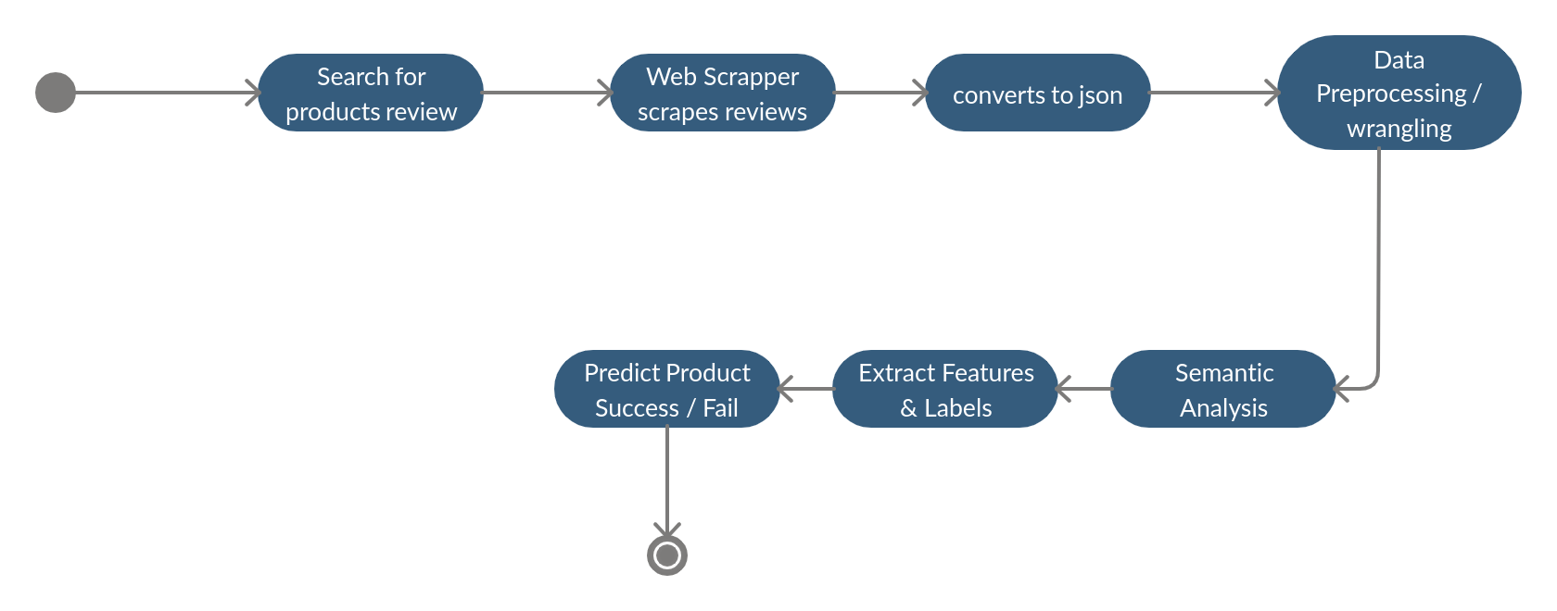

## 9.4 Sequence Diagram

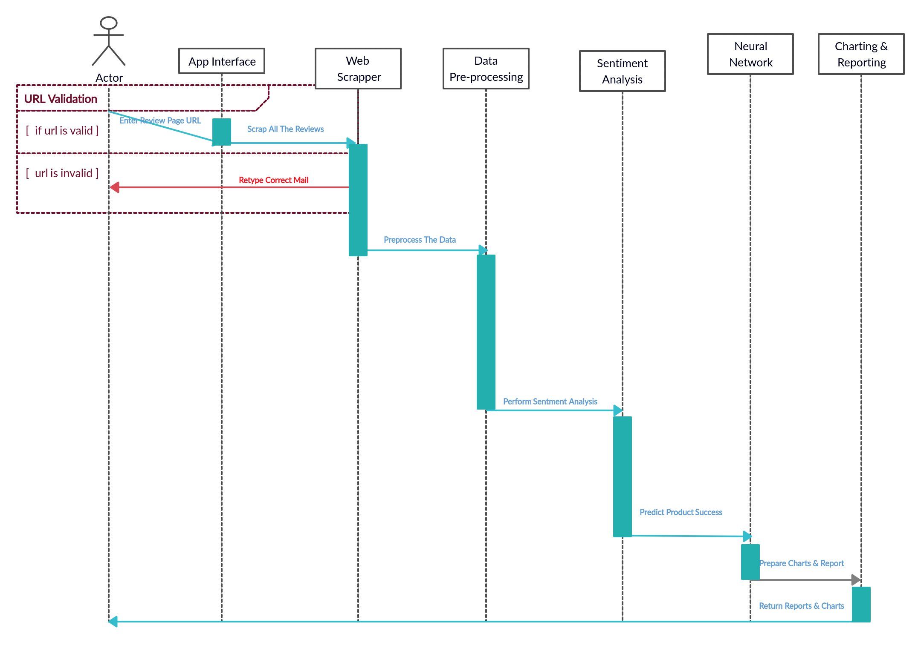

## 10. Preliminary Schedule

## 11. Preliminary Budget

|  |  |
| --- | --- |
| Google Cloud | 10,000 Rs. per month |
| Themes for Interface | 2,000 – 5,000 Rs. |

## 12. Appendices

Below are the references of existing systems to our project

**12.1 References**

<https://digitalmarketinginstitute.com/en-us/blog/the-what-why-and-how-of-360-degree-customer-view>

<https://www.lotame.com/us-data-to-get-a-360-degree-view-of-your-customers/>

<https://en.wikipedia.org/wiki/360-degree_feedback>

<https://en.wikipedia.org/wiki/Customer_analytics>

<https://medium.com/analytics-vidhya/using-nlp-on-amazon-echo-reviews-efb5078bf0d3>